BTRC ISP Self-Care Portal

User Interface Screenshots

December 2024

# Table of Contents

1. ISP Dashboard

2. Integration & Provisioning

3. BGP Routing Management

4. Security & Threat Center

5. Alerts & Notifications

6. Support Tickets

7. Document Management

8. ISP Registration

9. Settings

# ISP Dashboard

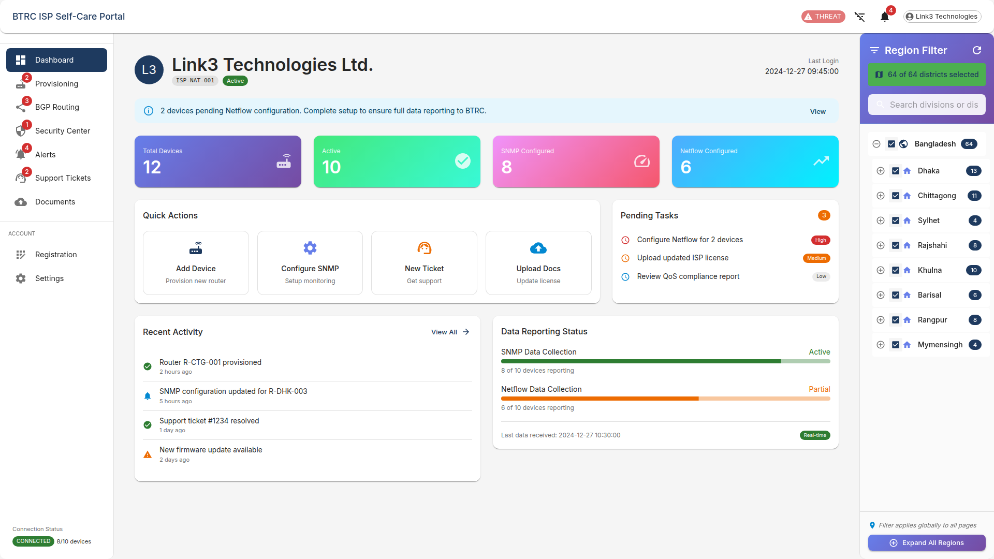

*Figure 1: ISP Dashboard - Home Page*

# Integration & Provisioning

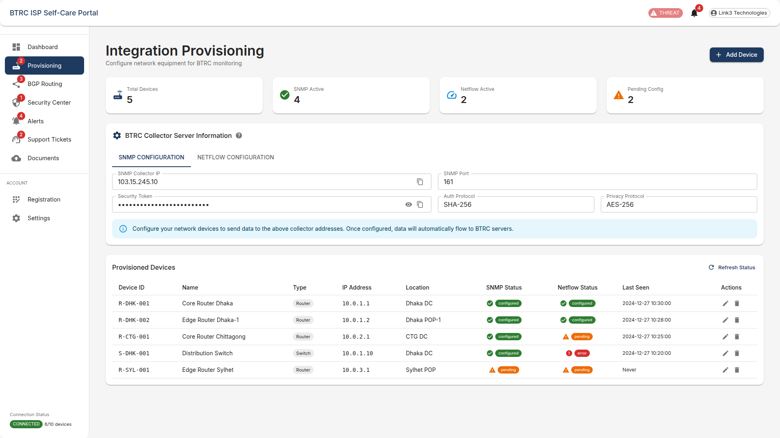

*Figure 2: Integration & Provisioning*

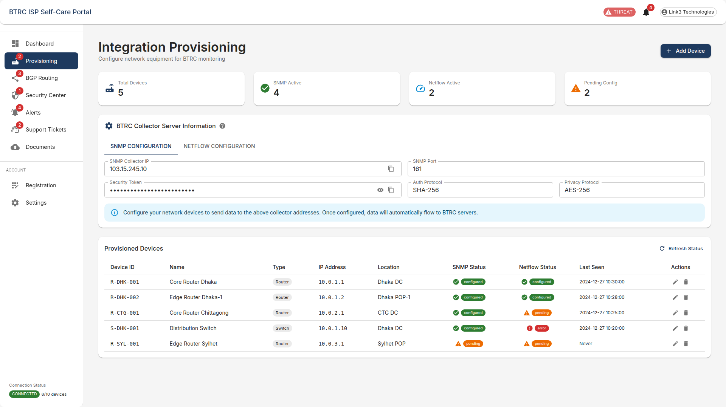

*Figure 3: Integration & Provisioning - SNMP Configuration Tab*

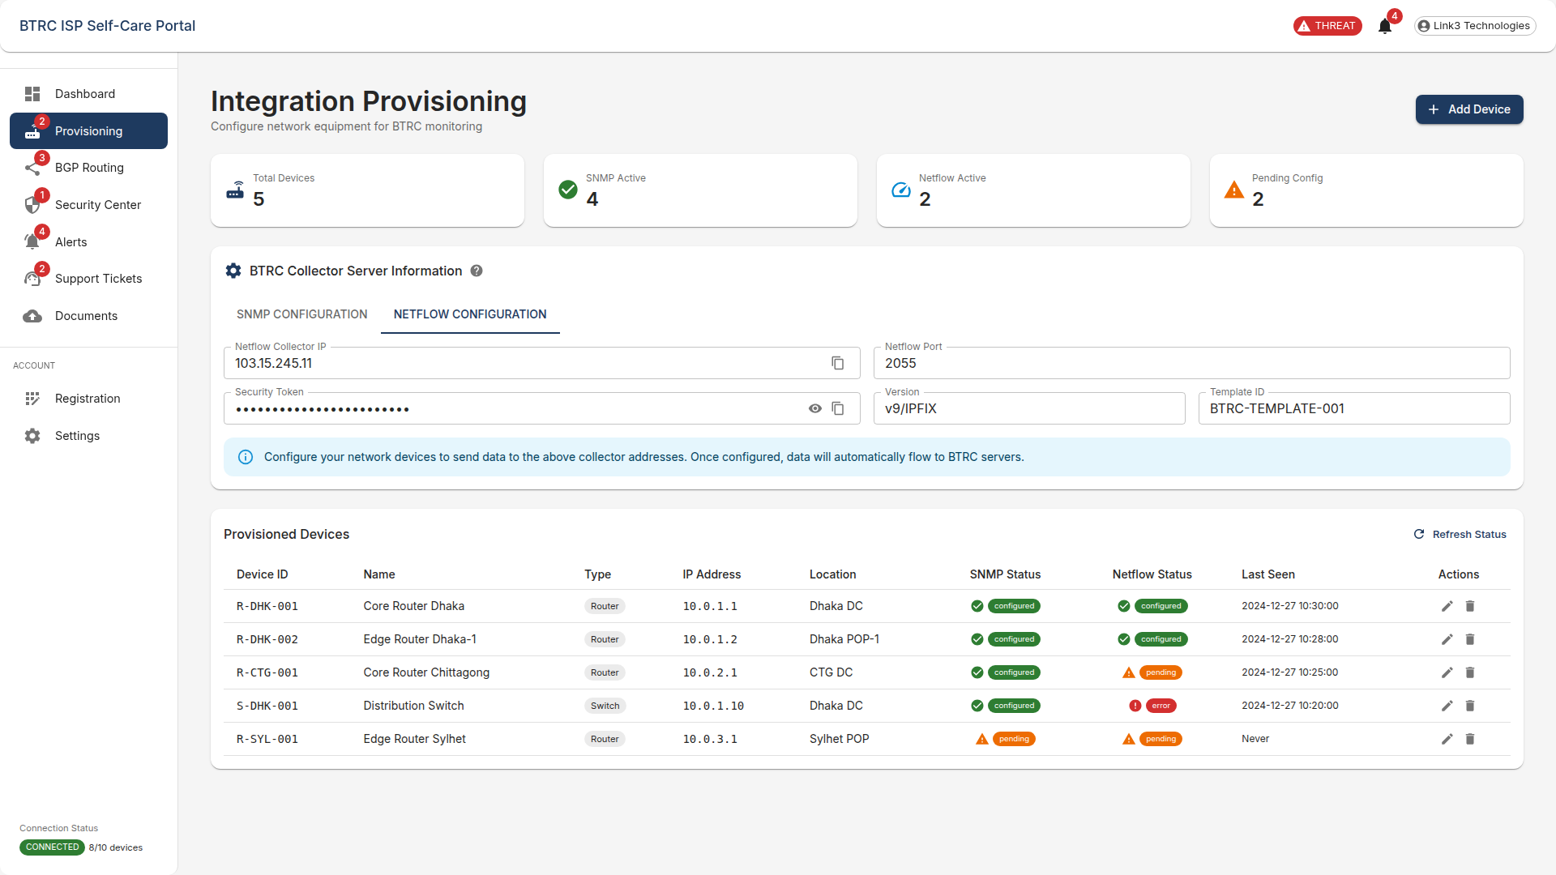

*Figure 4: Integration & Provisioning - Netflow Configuration Tab*

# BGP Routing Management

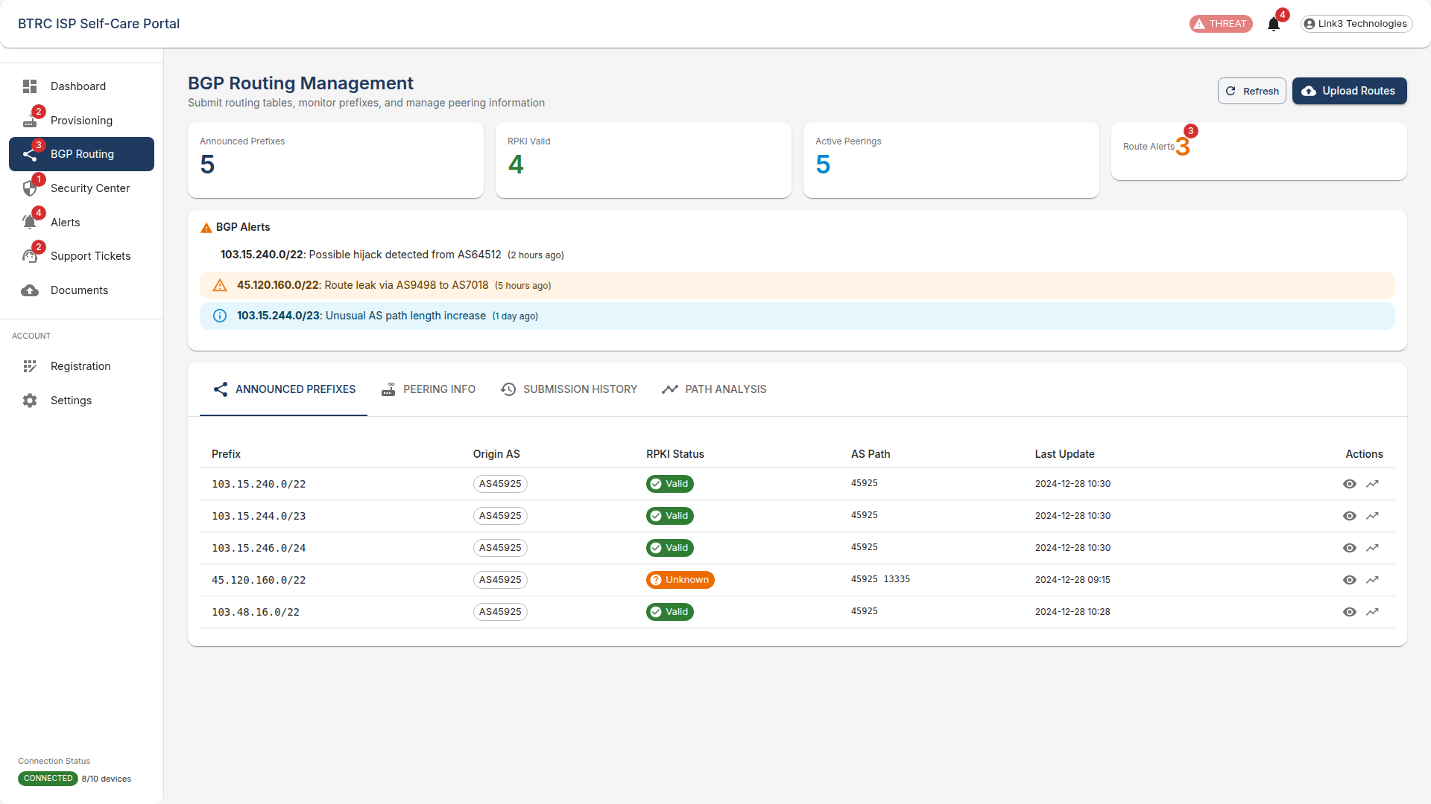

*Figure 5: BGP Routing Management*

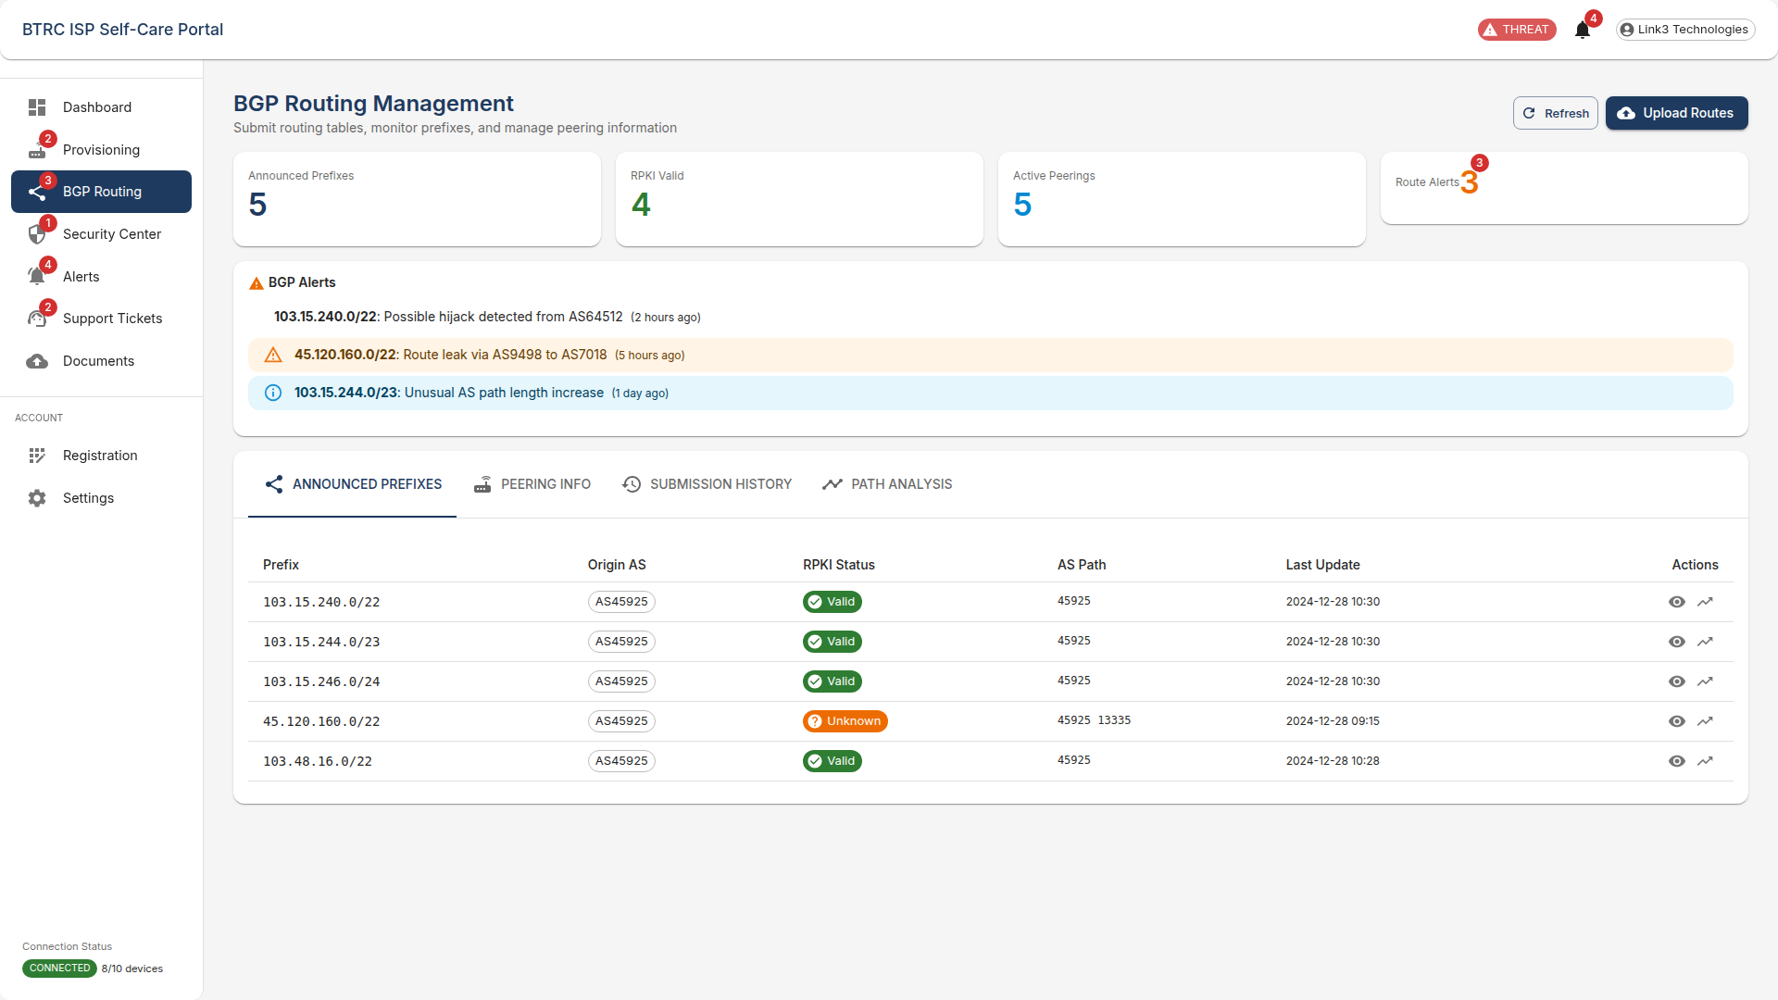

*Figure 6: BGP Routing Management - Announced Prefixes Tab*

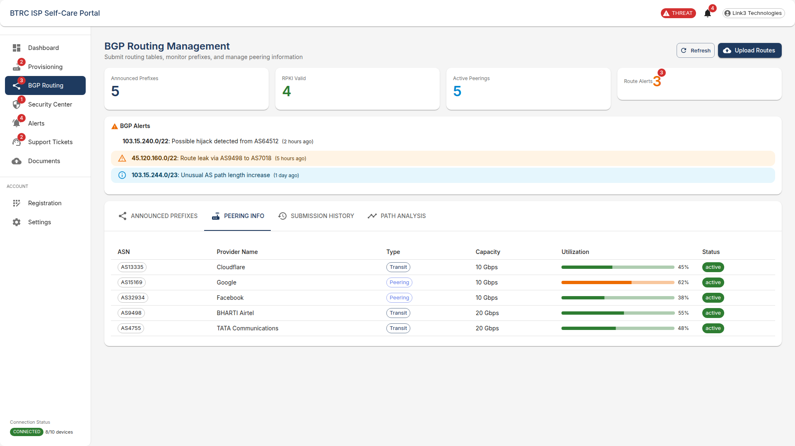

*Figure 7: BGP Routing Management - Peering Info Tab*

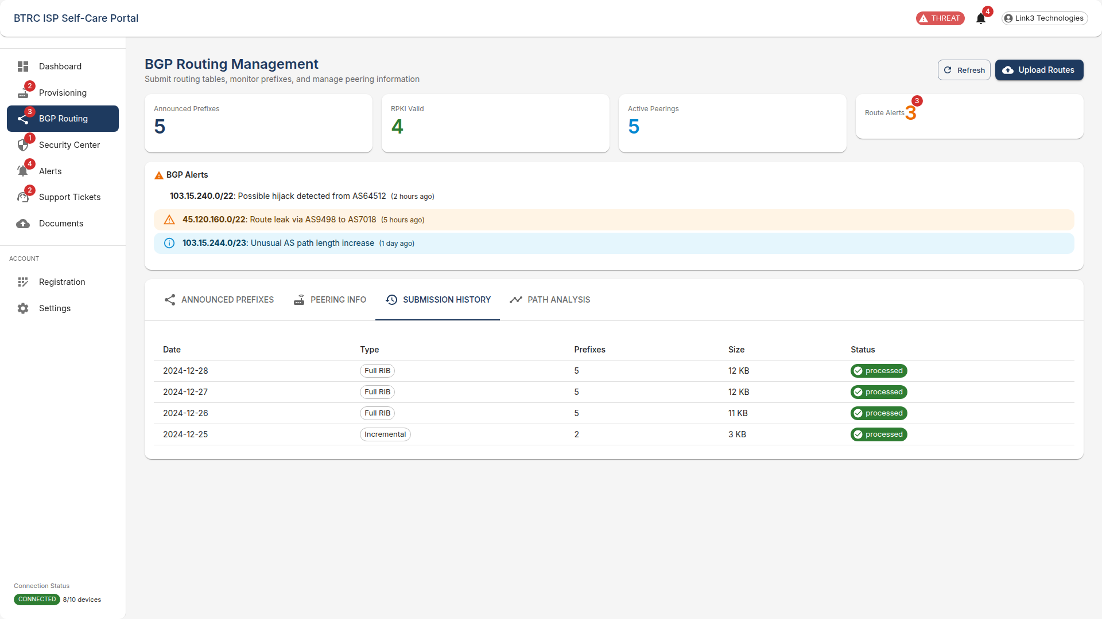

*Figure 8: BGP Routing Management - Submission History Tab*

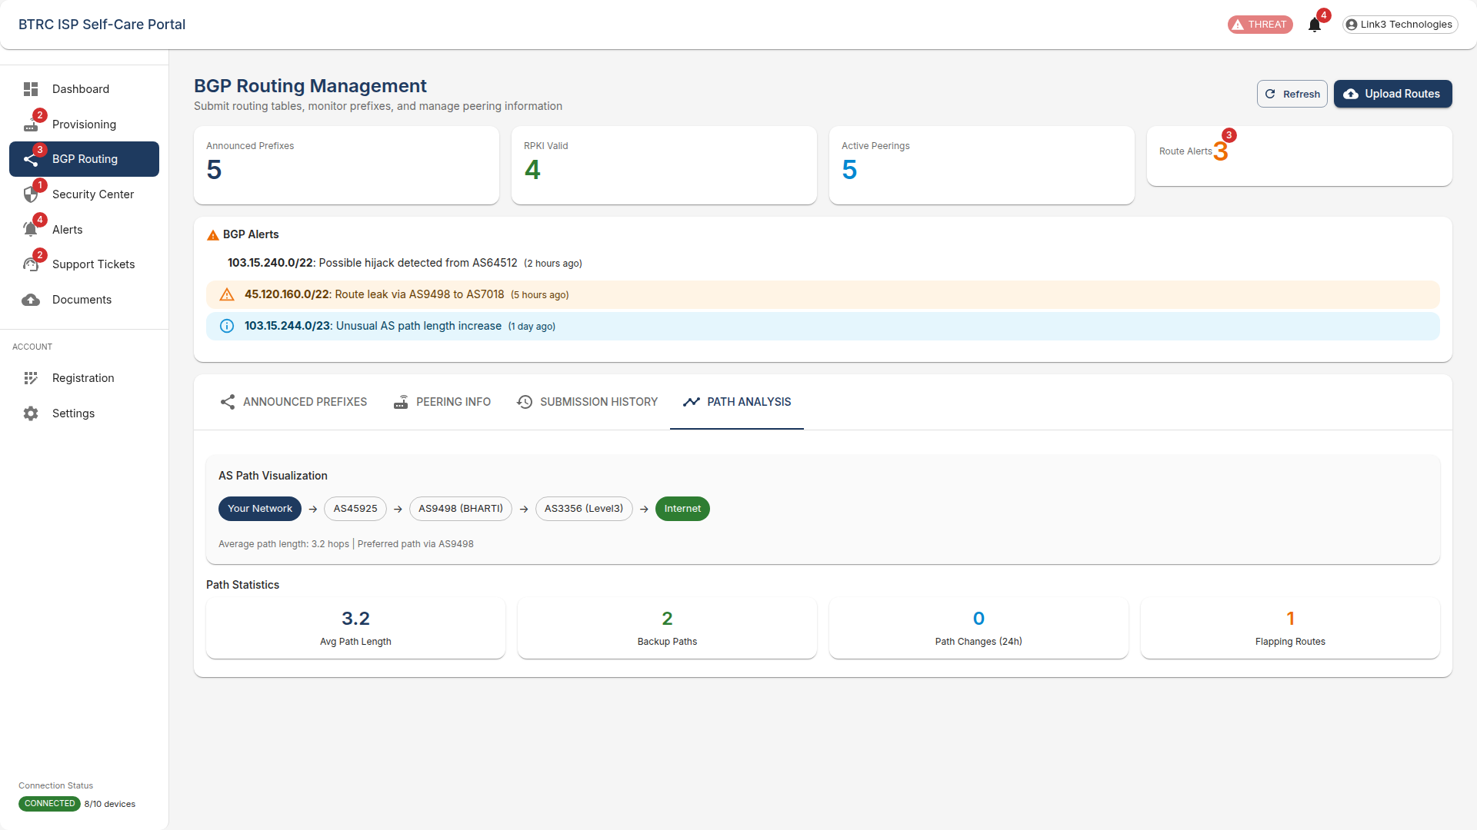

*Figure 9: BGP Routing Management - Path Analysis Tab*

# Security & Threat Center

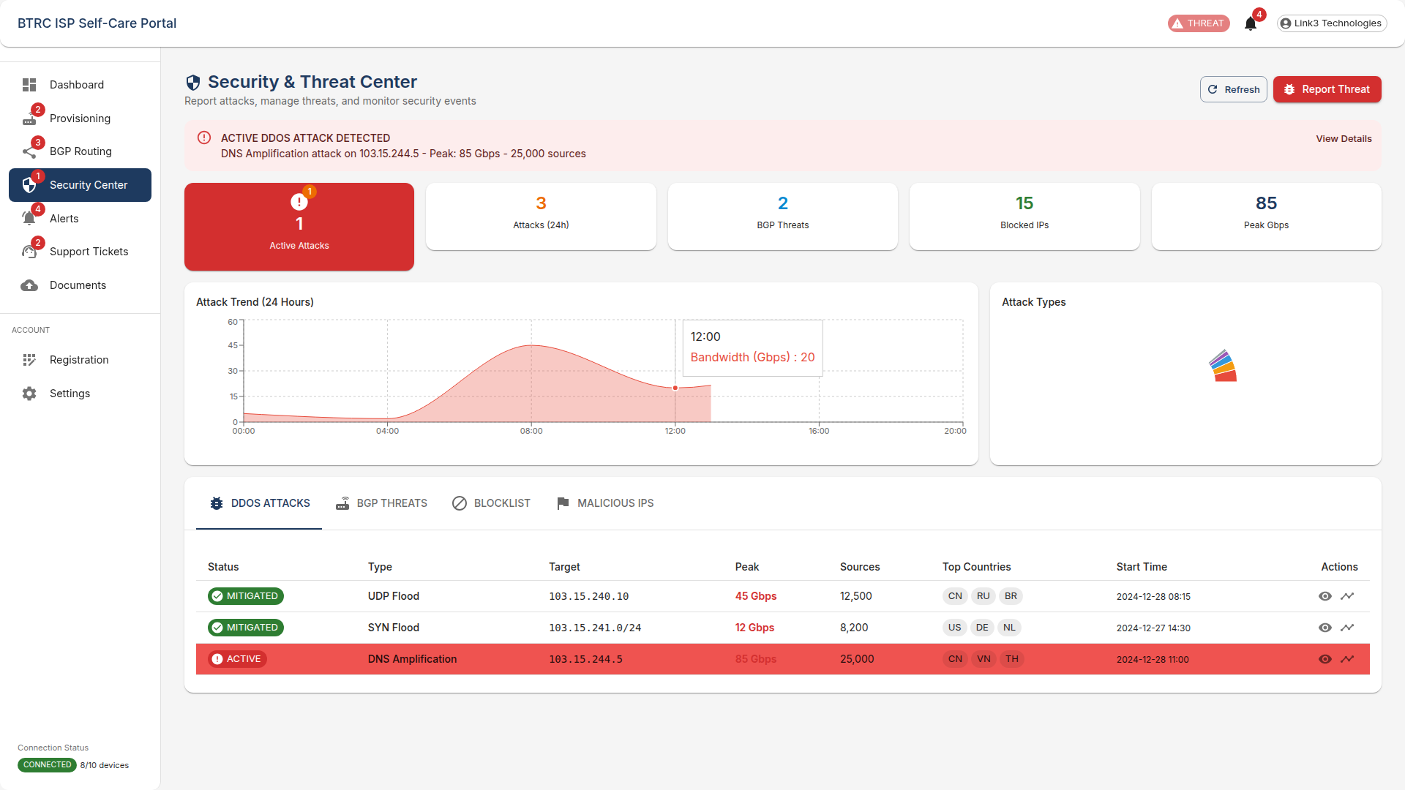

*Figure 10: Security & Threat Center*

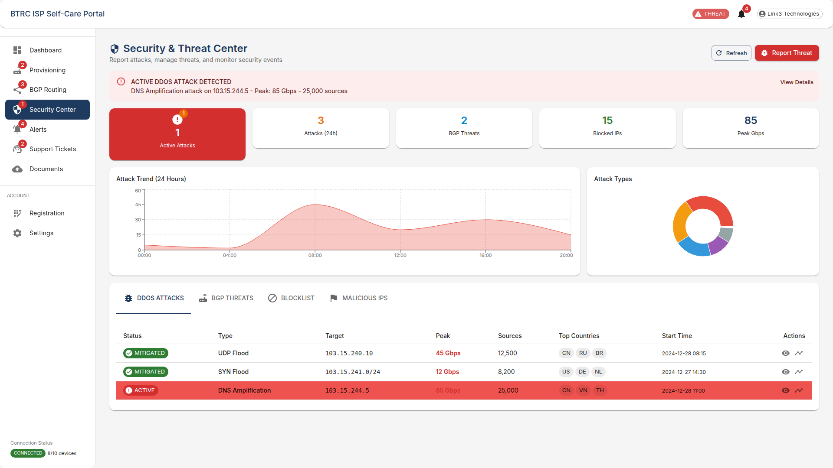

*Figure 11: Security & Threat Center - DDoS Attacks Tab*

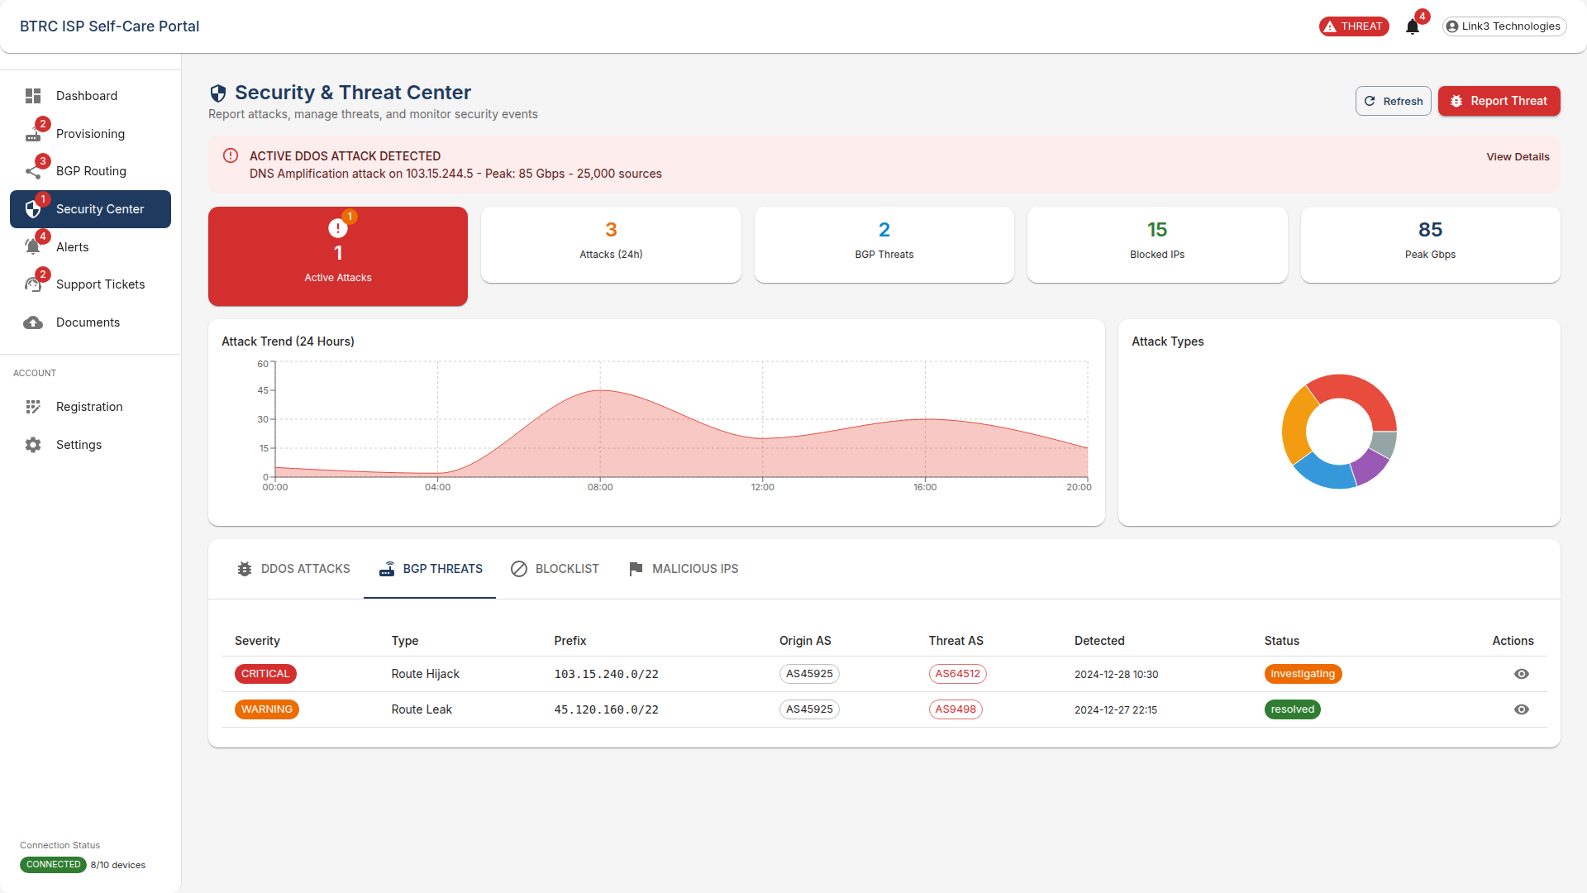

*Figure 12: Security & Threat Center - BGP Threats Tab*

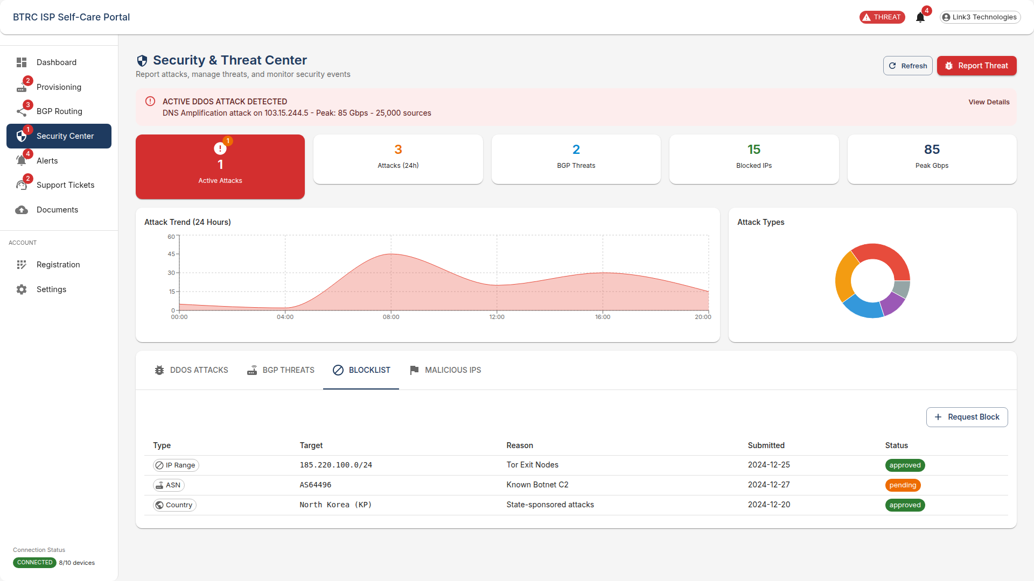

*Figure 13: Security & Threat Center - Blocklist Tab*

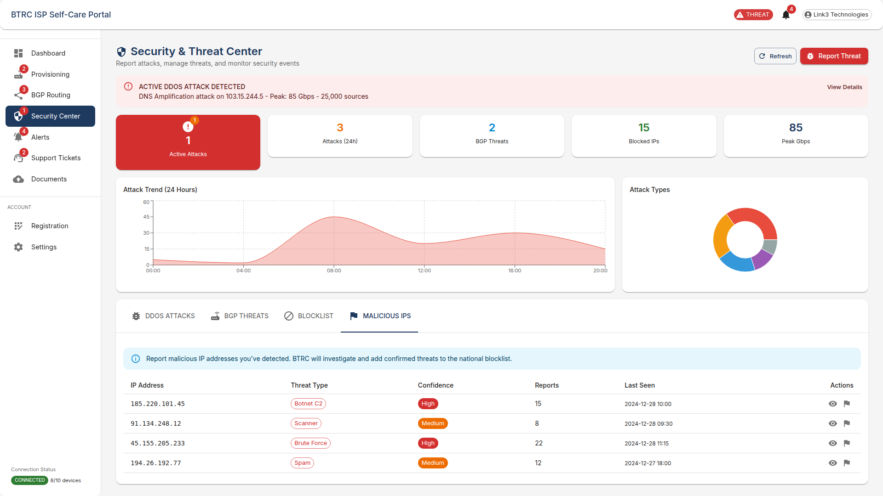

*Figure 14: Security & Threat Center - Malicious IPs Tab*

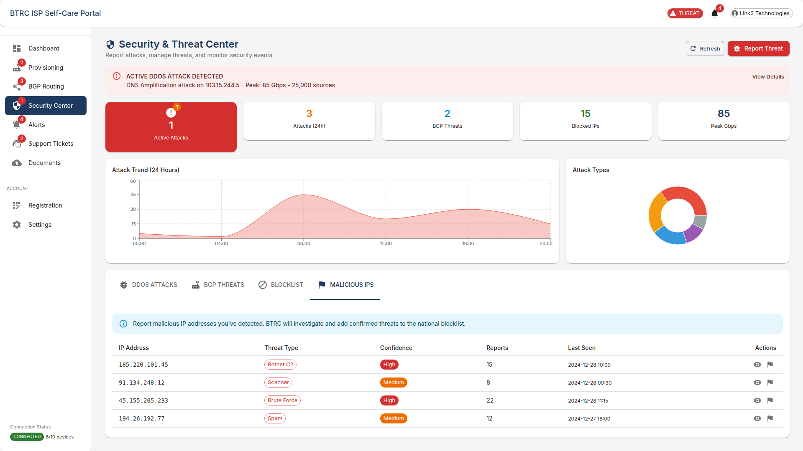

*Figure 15: Security & Threat Center - Malicious IPs Tab (continued 2)*

# Alerts & Notifications

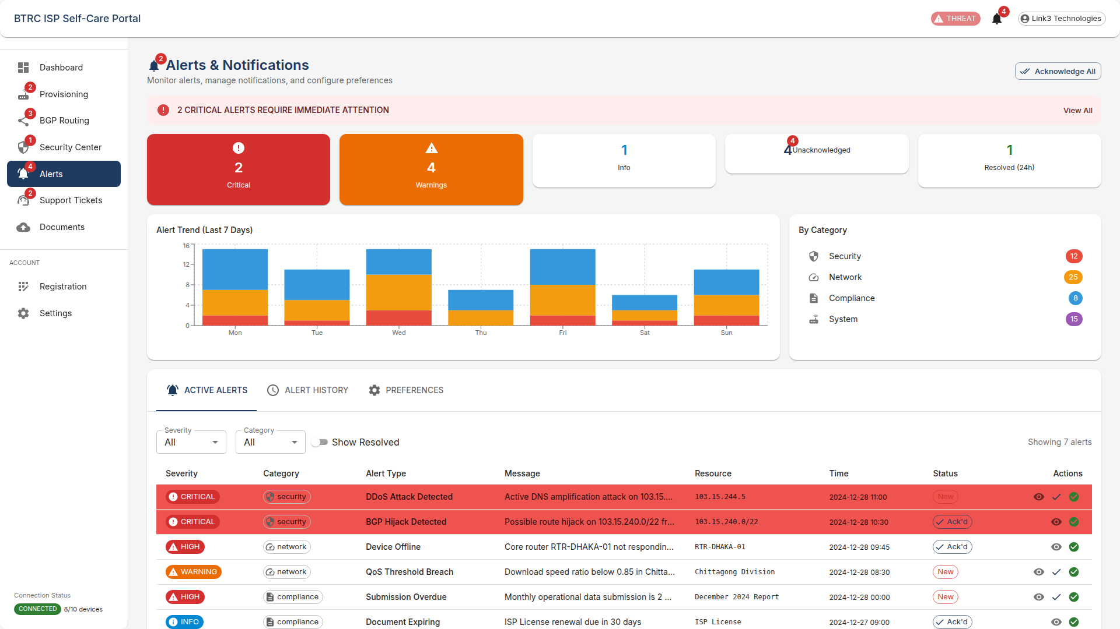

*Figure 16: Alerts & Notifications*

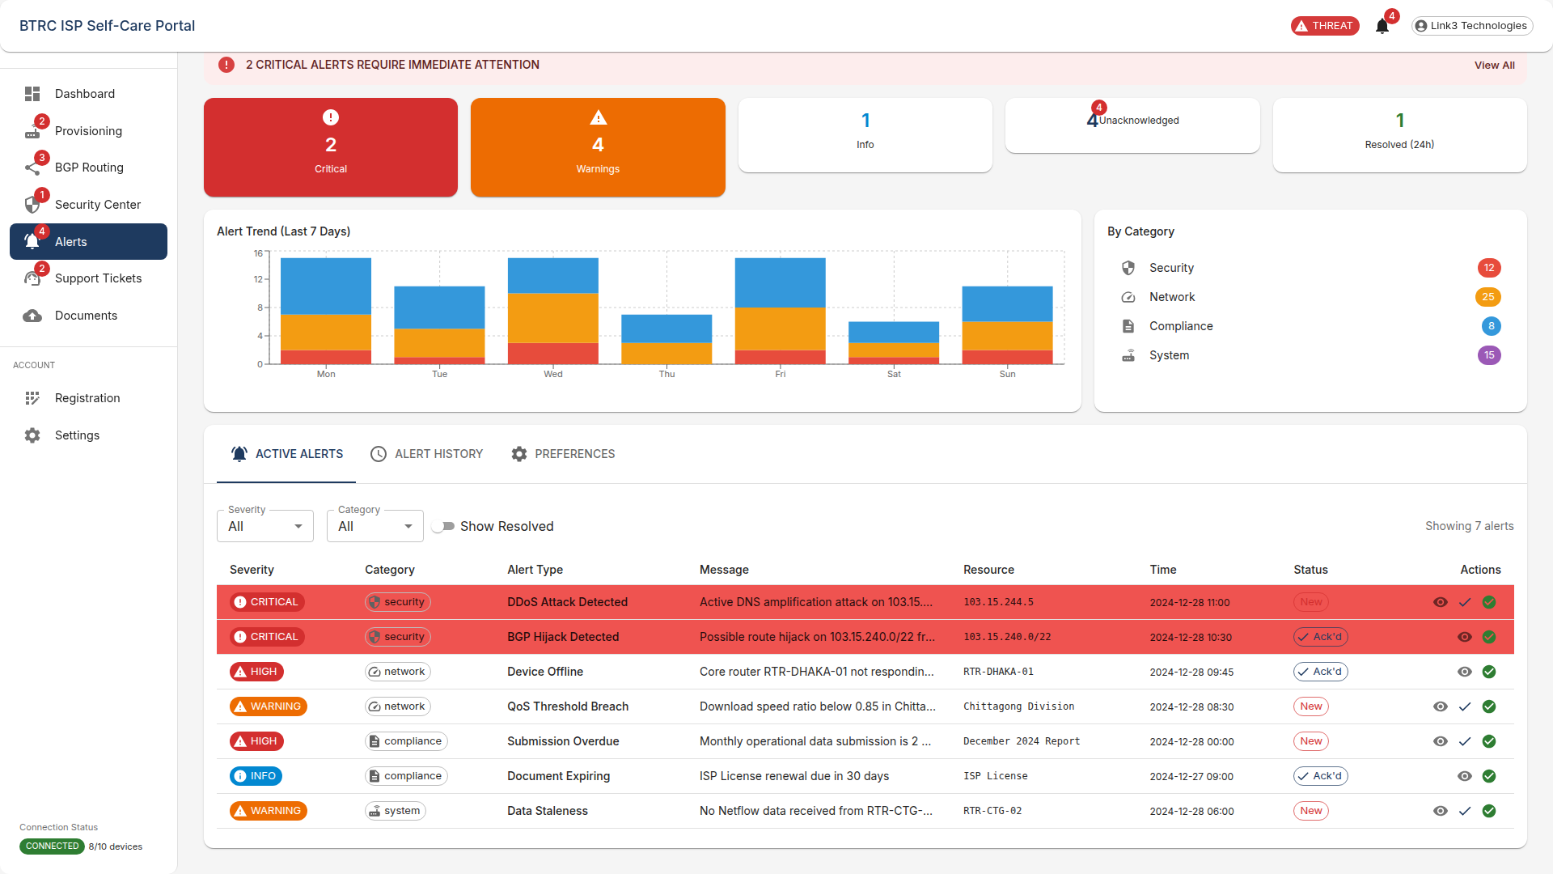

*Figure 17: Alerts & Notifications (continued 2)*

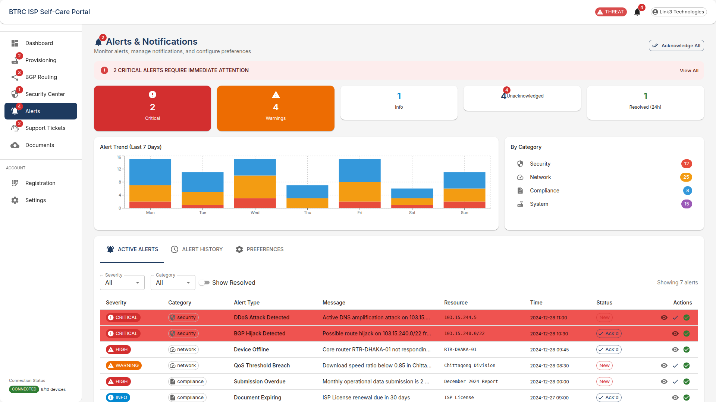

*Figure 18: Alerts & Notifications - Active Alerts Tab*

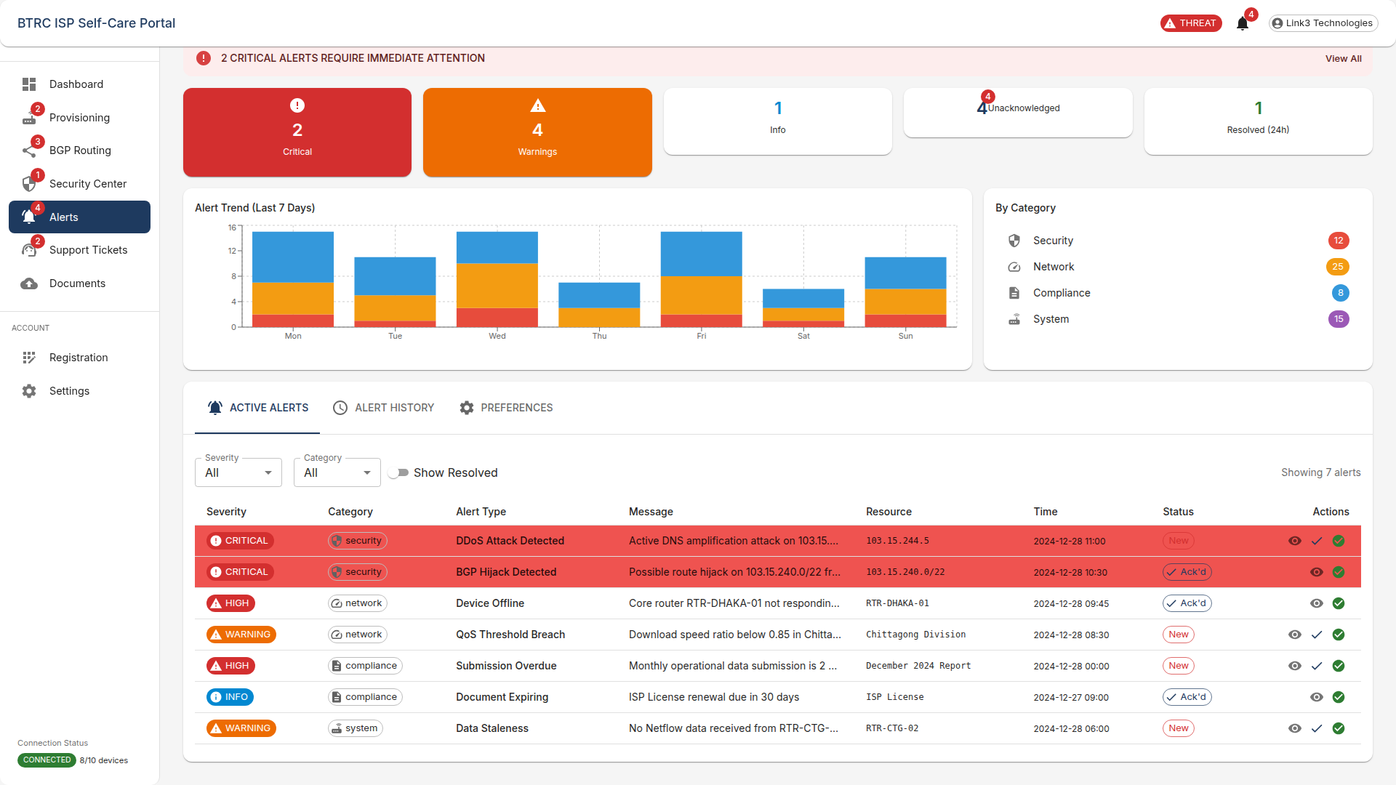

*Figure 19: Alerts & Notifications - Active Alerts Tab (continued 2)*

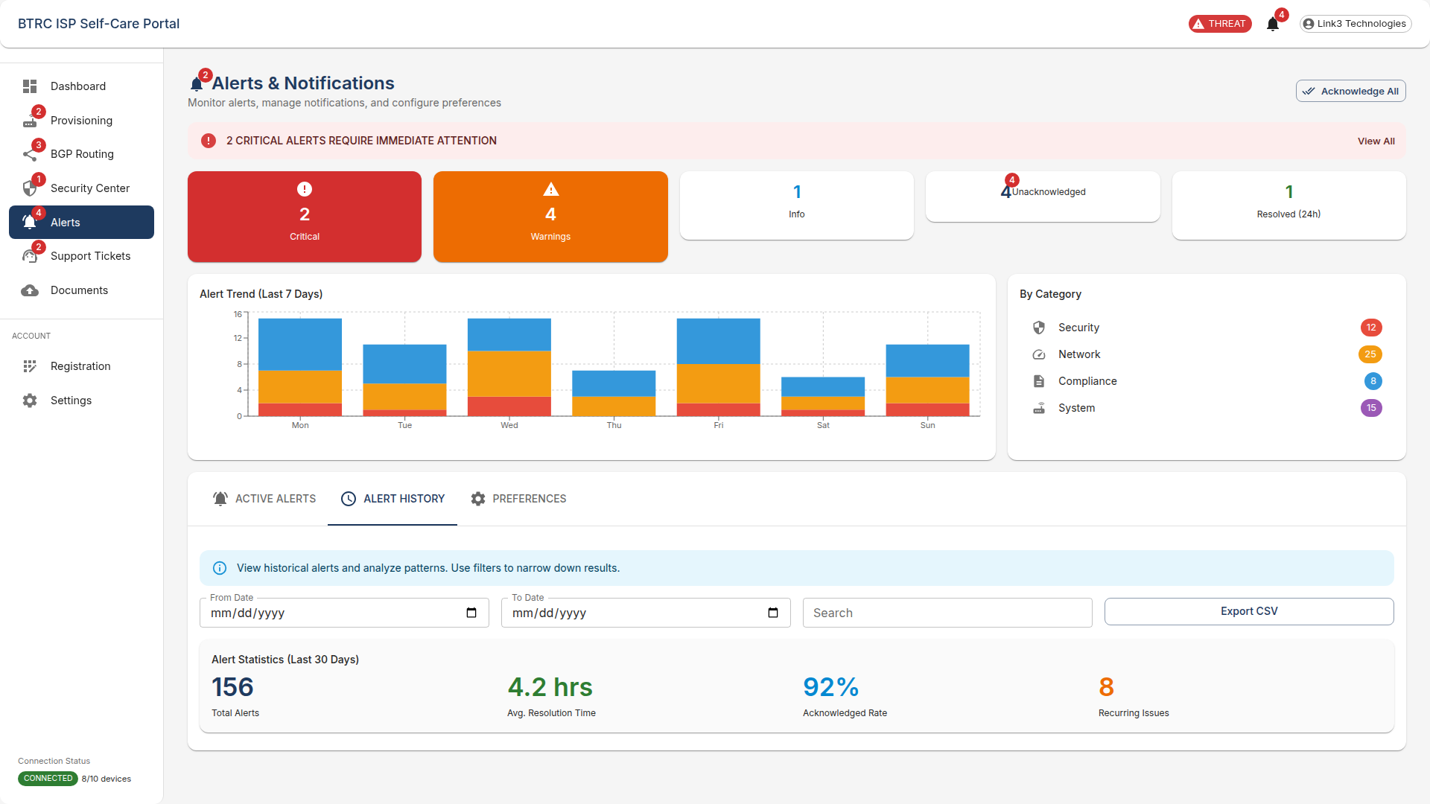

*Figure 20: Alerts & Notifications - Alert History Tab*

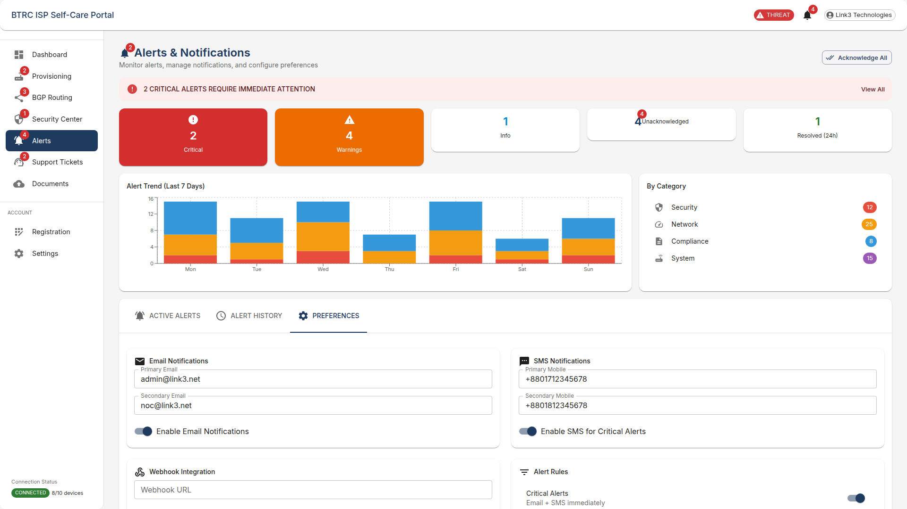

*Figure 21: Alerts & Notifications - Preferences Tab*

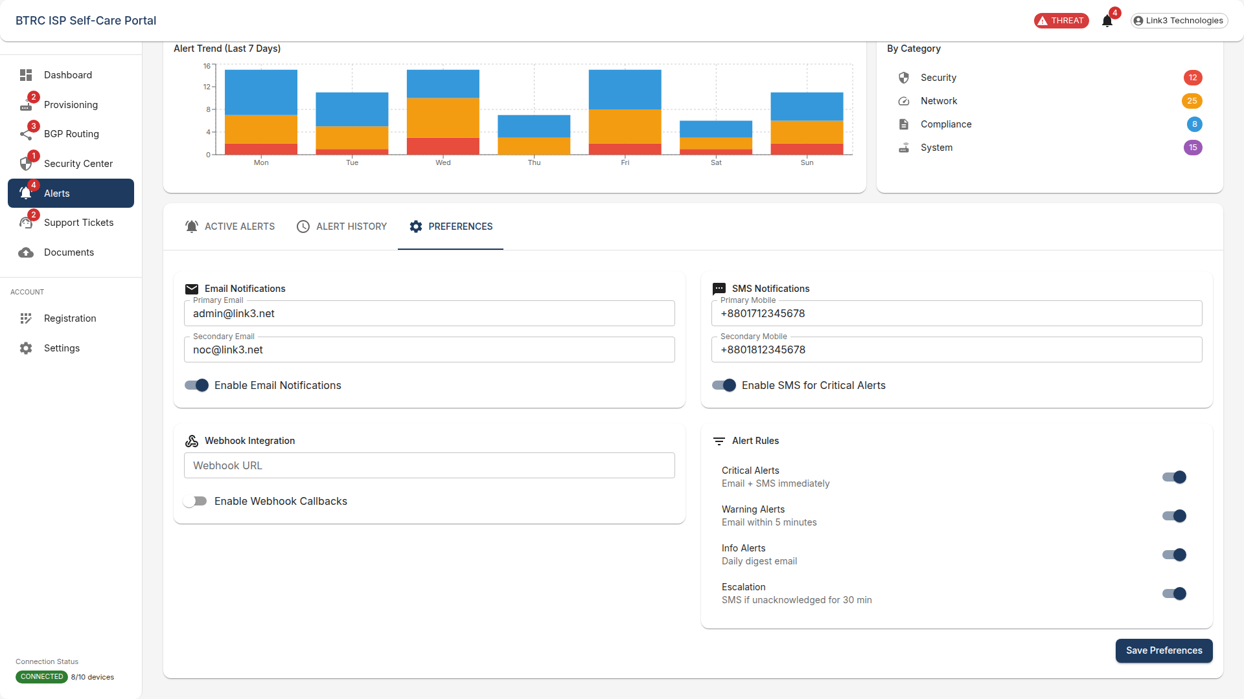

*Figure 22: Alerts & Notifications - Preferences Tab (continued 2)*

# Support Tickets

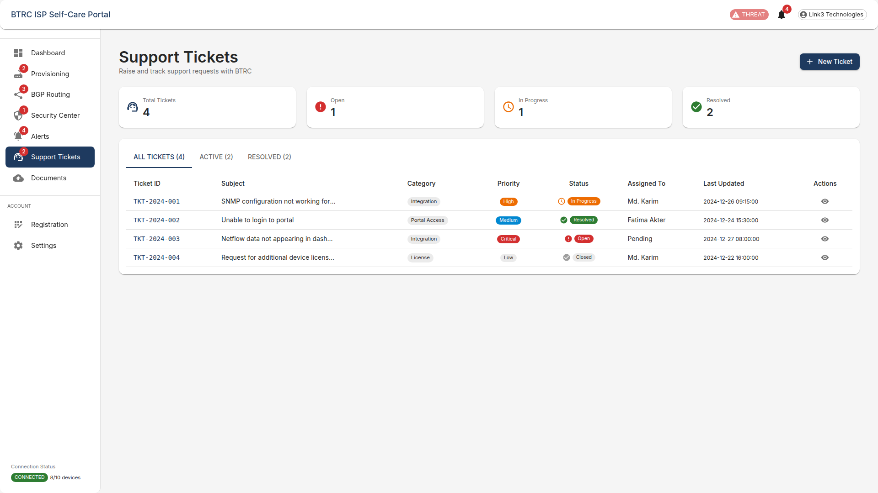

*Figure 23: Support Tickets*

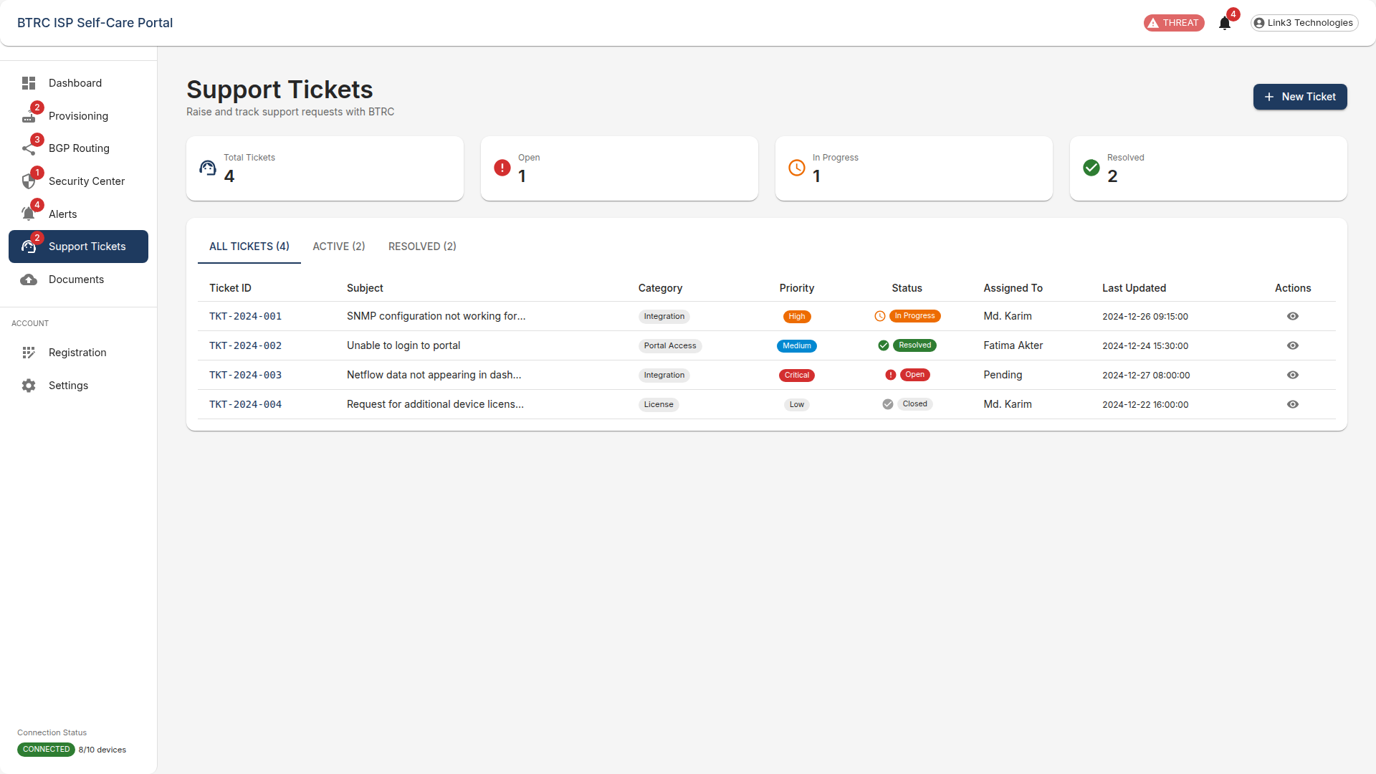

*Figure 24: Support Tickets - All Tickets (4) Tab*

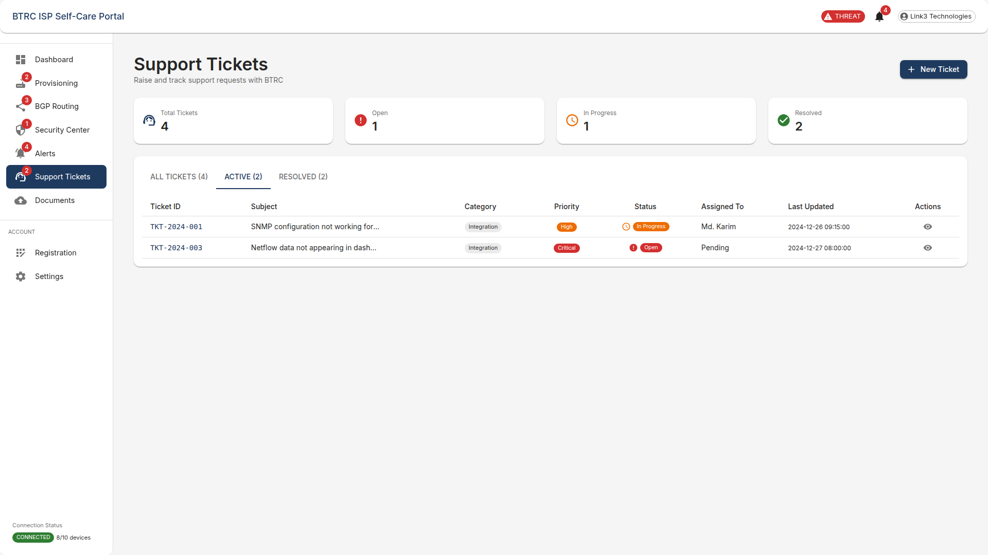

*Figure 25: Support Tickets - Active (2) Tab*

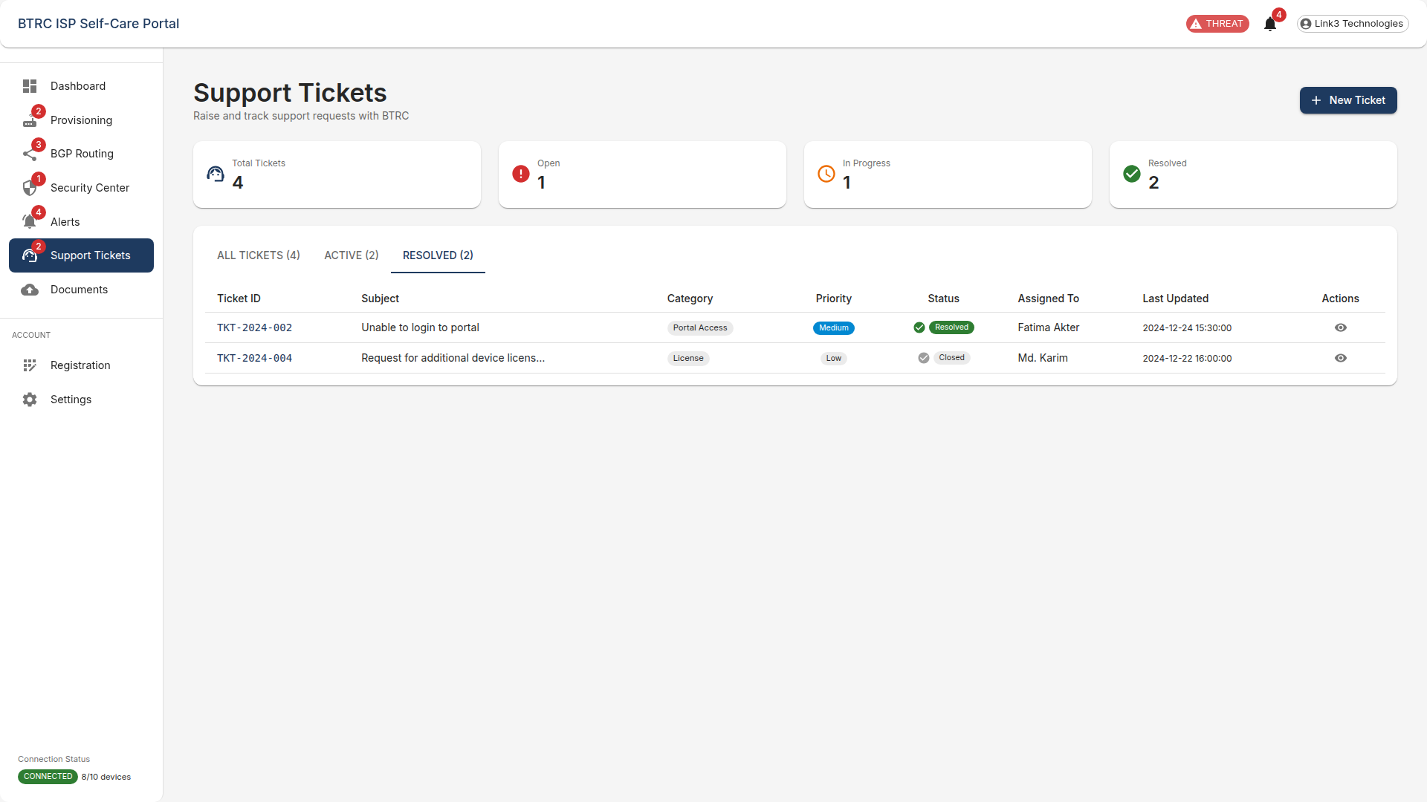

*Figure 26: Support Tickets - Resolved (2) Tab*

# Document Management

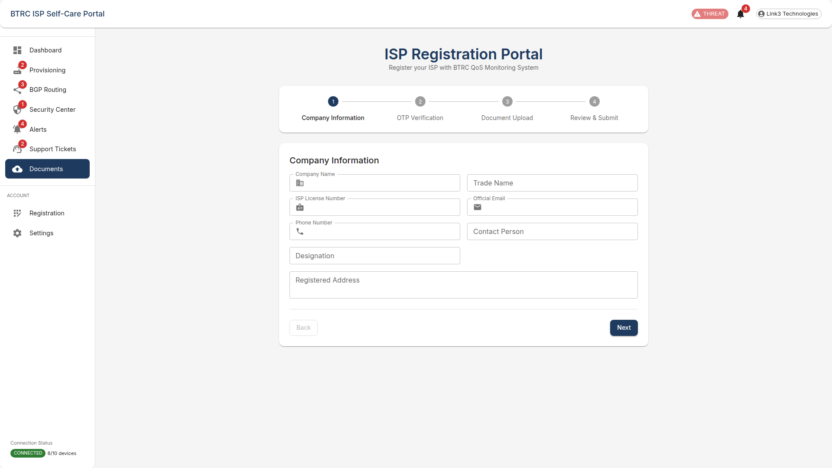

*Figure 27: Document Management*

# ISP Registration

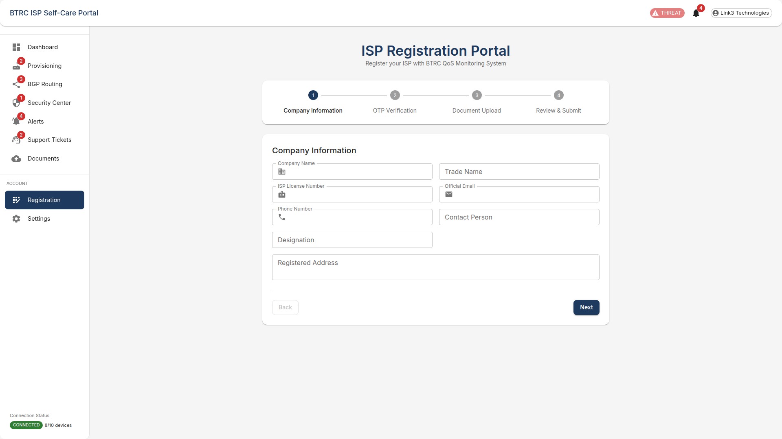

*Figure 28: ISP Registration*

# Settings

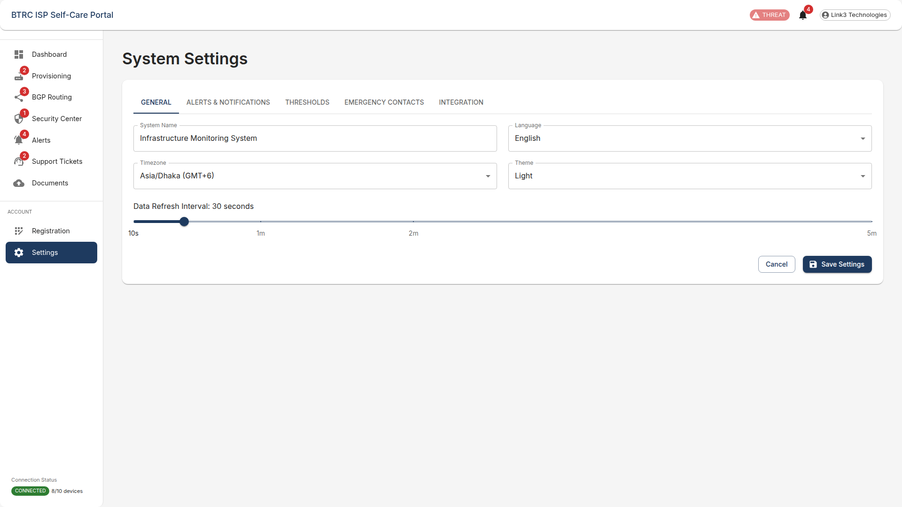

*Figure 29: Settings*

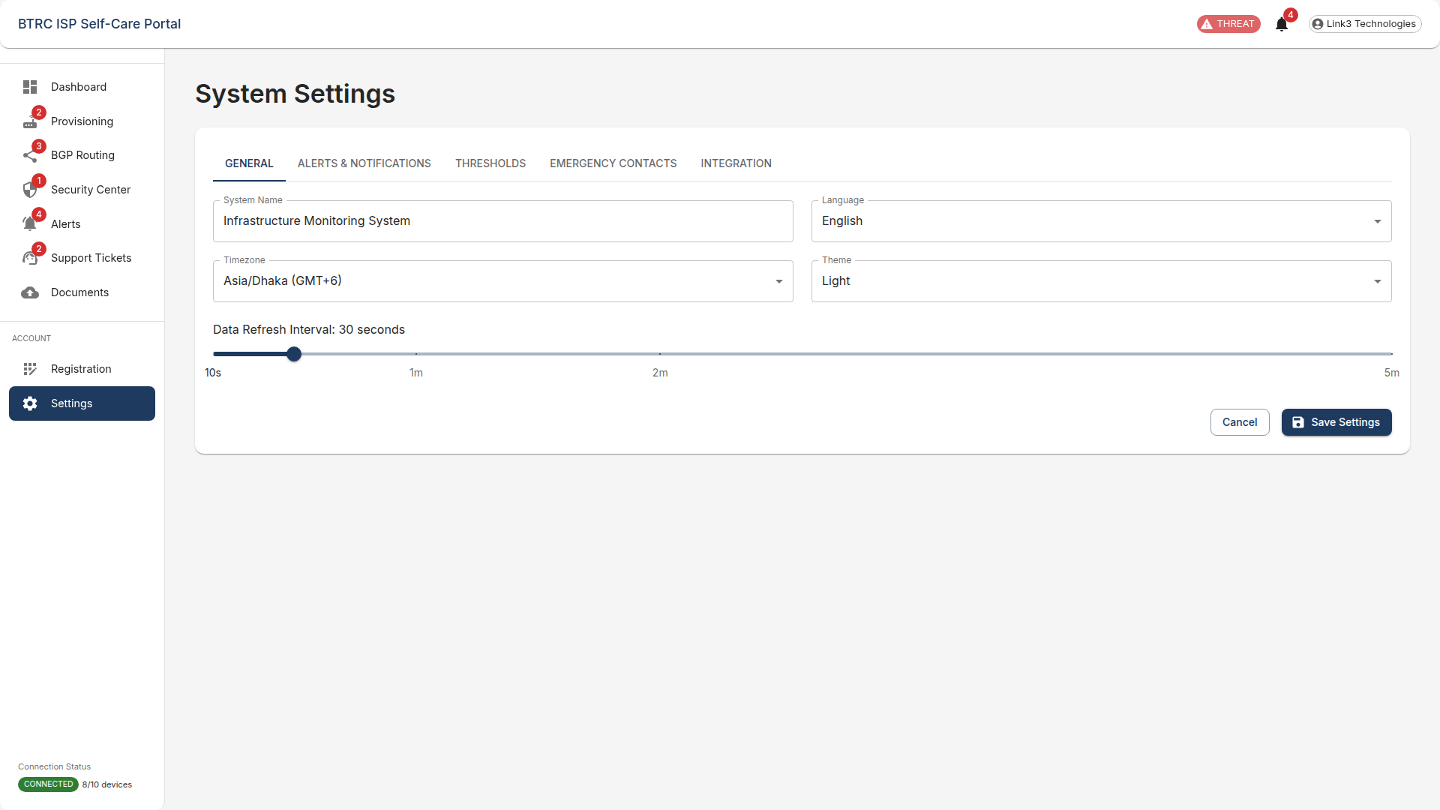

*Figure 30: Settings - General Tab*

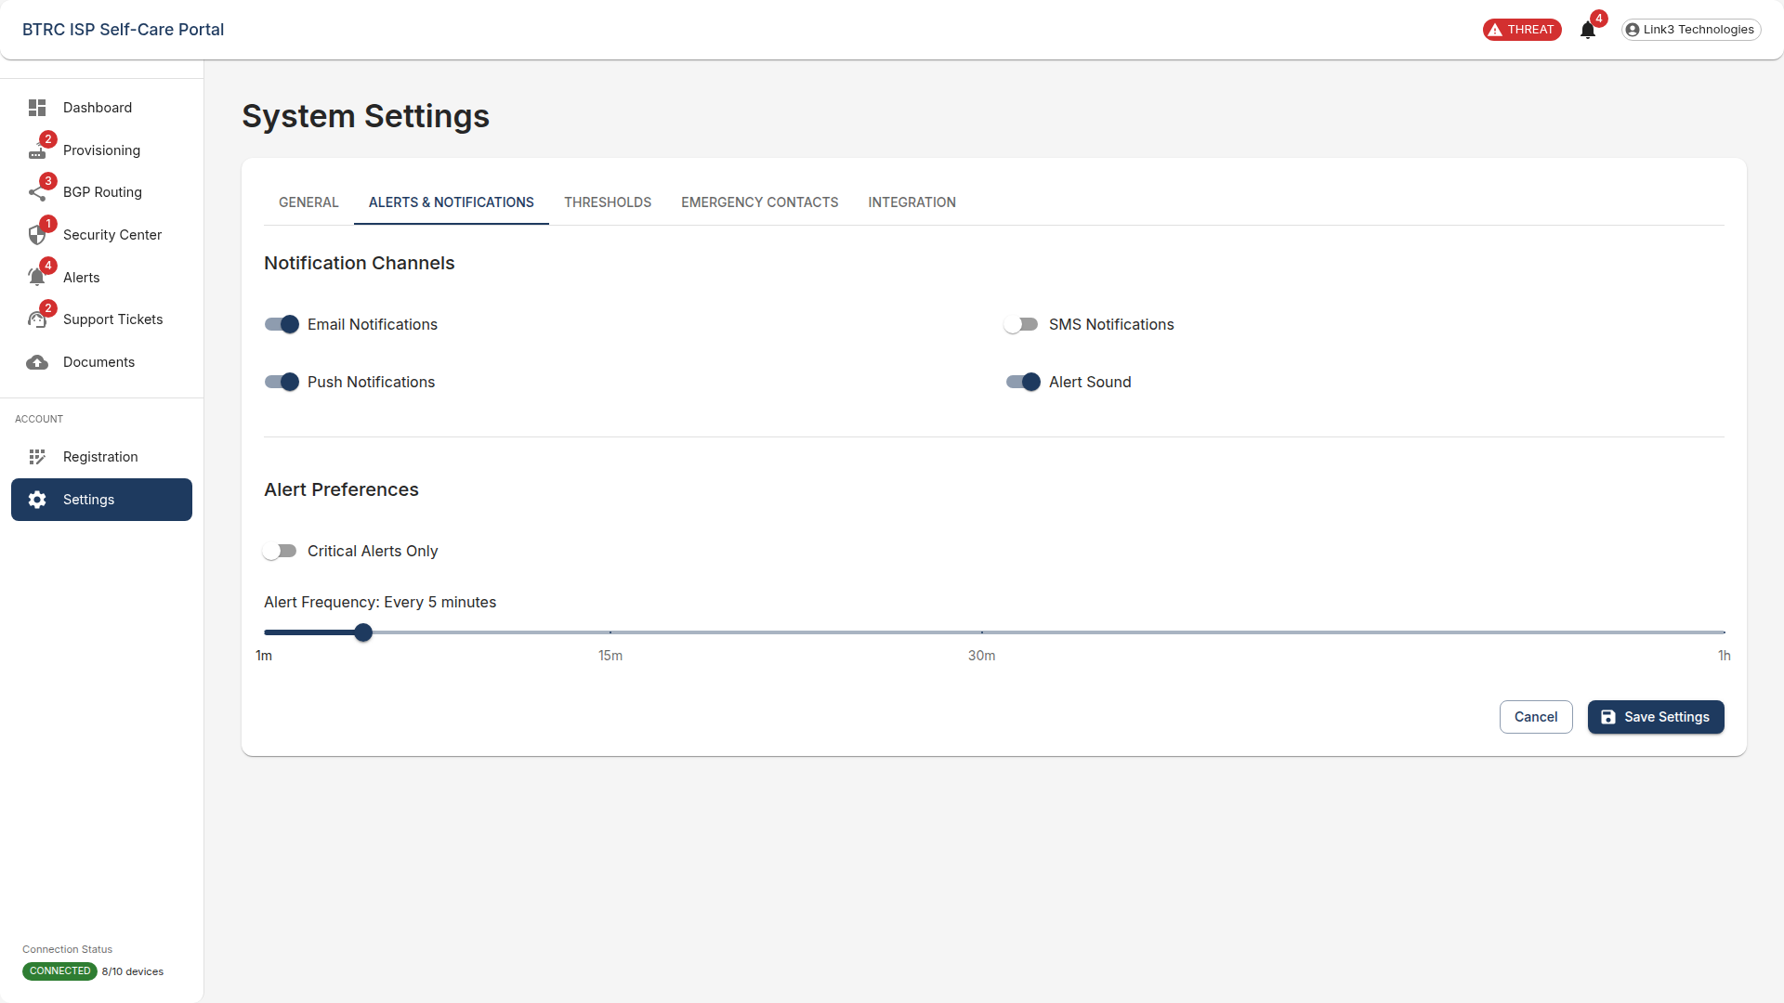

*Figure 31: Settings - Alerts & Notifications Tab*

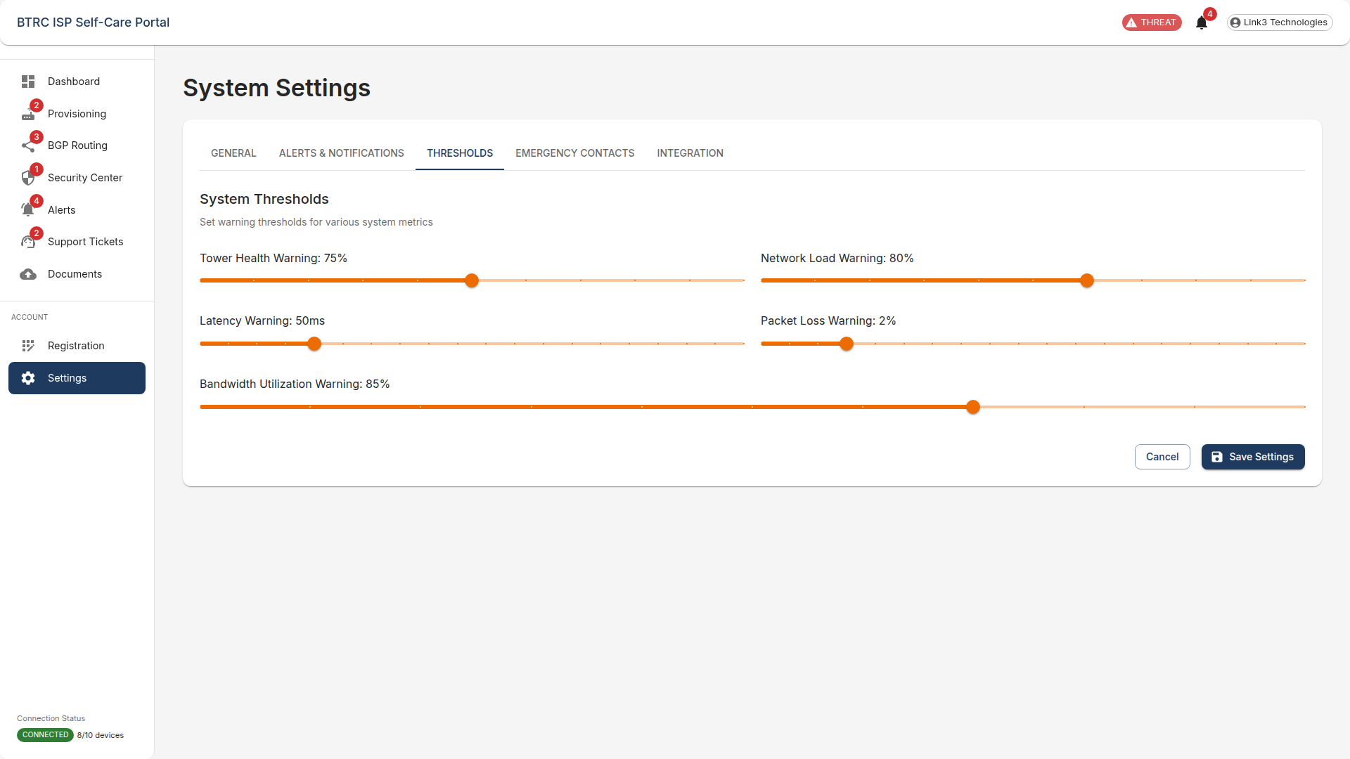

*Figure 32: Settings - Thresholds Tab*

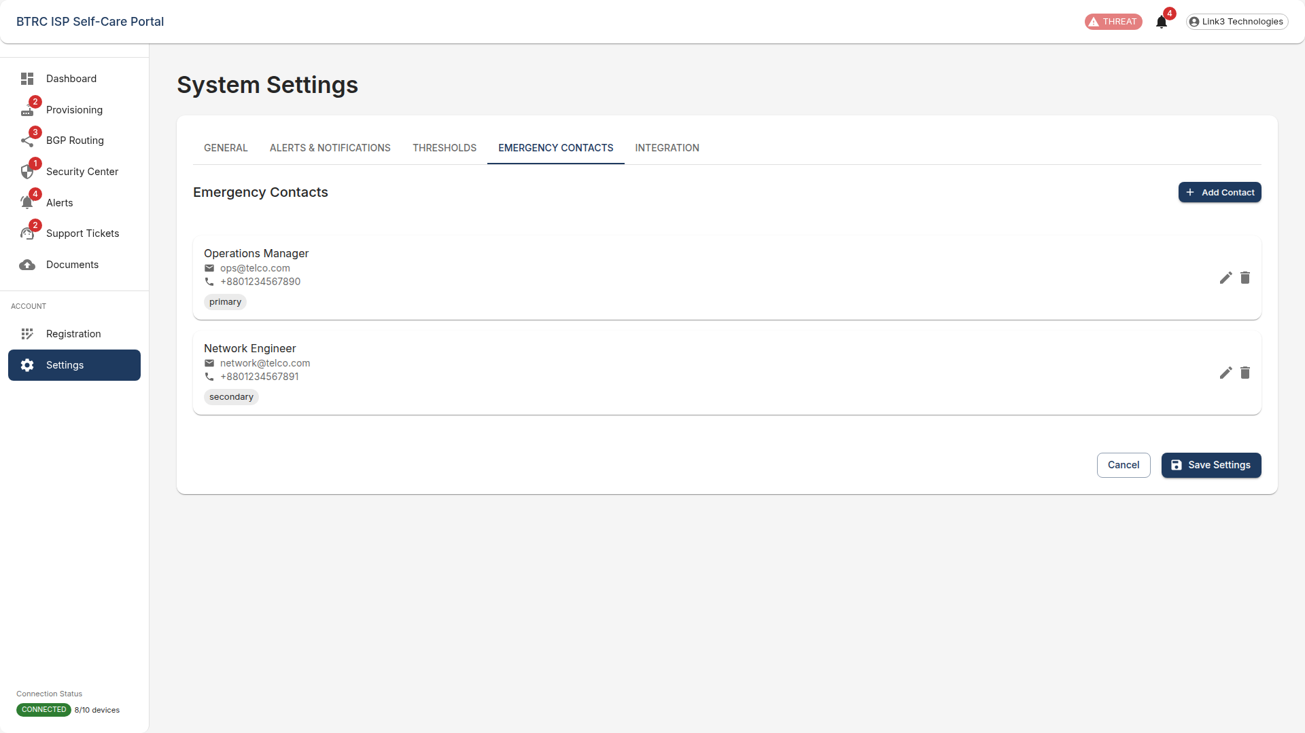

*Figure 33: Settings - Emergency Contacts Tab*

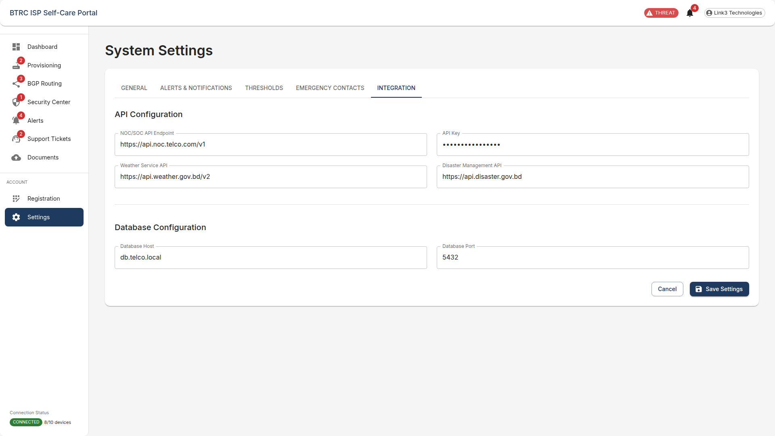

*Figure 34: Settings - Integration Tab*